**Assignment for Data Analyst Role**

**1. Please provide steps to convert an epoch Timestamp to**

**a. Datetime value**

**b. Date value**

**with any visualisation/wrangling tool except google sheets and Microsoft Excel.**

**- The candidate is expected to perform the given steps during the interview call.**  
**Solution:** Here is the approach to achieve the desired result using various tools: Python, SQL and Power BI

**Python:**

* With the help of pandas library conversion of epoch time to date value and extracting date part is easier with the help of to_datetime()

1. First step is import the pandas library.
2. Next is get the epoch_time which is to be coverted.
3. Third step is using the to_datetime()function pass the arguments mentioning unit within seconds as “s”
4. Print the result.
5. For extracting the datepart use the date() function and print the result.  
     
   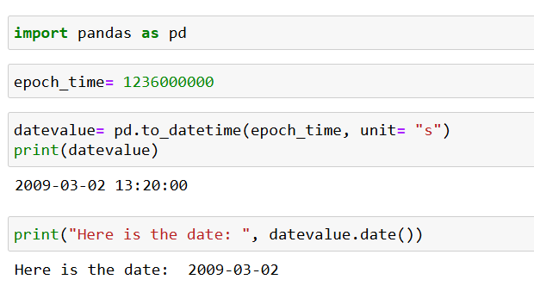

**SQL Server:**

* With the help of SQL Server we are required to add number of seconds to the date value to 1970-01-01 and to get the date part use CAST with the same quey and mention AS DATE to get the date.   
  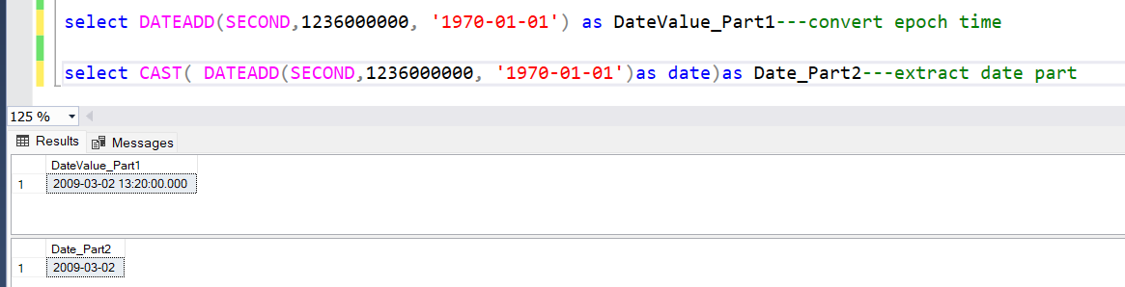

**Power BI:** Using the DAX we can achieve the similar result:  Datevalue = DATE(1970,1,1) + ('Date'[Epoch] / 86400) here 86400 is the number of seconds in one day.  
  
  
**2. Make a copy of the link here to solve the other sheets (Sheet2, Sheet3, Sheet4) for achieving “Desired Result” sheet format. Constraints to solution are mentioned below:  
a. Only use formulae to complete the task, no copy pasting is allowed.  
b. The formulae should only be used in one of the sheets (Sheet2, Sheet3, Sheet4).  
c. Candidates able to get the “Desired Result” by putting in the formula in just one cell would get the preference.**

**Solution:** To achieve the “Desired Result” as mentioned within the sheet labelled as “Desired Result”; I used Sheet 4 for the formula. The reason behind is Sheet 4 Columns has a matching order with the sheet “Desired Result”. The formula that helped to get the result using one cell is mentioned below:  
  
=TEXTSPLIT(TEXTJOIN(",",TRUE,XLOOKUP(B1,Sheet3!A:A,Sheet3!B:B,"",0),XLOOKUP(XLOOKUP(B1,Sheet3!A:A,Sheet3!B:B,"",0),Sheet2!A:A,Sheet2!B:B,"",0)),",")  
  
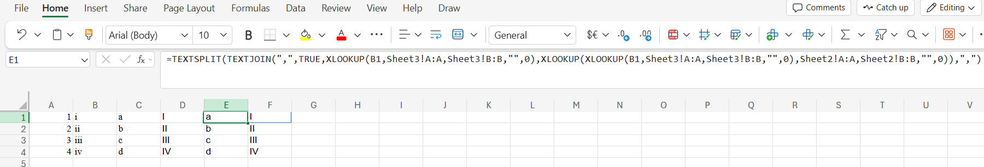There are certainly four parts of the above formula:

1. First XLOOKUP(highlighted in green) is fetching the value on the basis of roman numbers in small letters.
2. Second XLOOKUP (highlighted in blue) is looking for the value on the basis of result achieved from first XLOOKUP.
3. Both results are being joined using TEXTJOIN on the basis of comma delimiter as highlighted in yellow.
4. Last part is TEXTSPLIT which is being used to get the result in two different columns as highlighted in red.

Here we would be writing the formula within one cell but we would be getting the result as mentioned in “Desired Result” Sheet. [Click here for the Excel Sheet with the formula](https://1drv.ms/x/c/29f37f7e82fb0b4e/ETo7KTL-ZnpMqtry_eseEagB8kTNaPZLfq54YCkEjuJ_QQ?e=mkzZaD)  
  
**3. Build a dashboard in a visualisation tool of your choice which highlights various KPIs for at least five departments.  
a. You can choose the visualisations, number of pages, departments and KPIs as per your wish.**